Lab-18 (Numpy Function)

1. Suppose you have a dataset containing daily temperature readings for a city, and you want to identify days with extreme temperature conditions. Find days where the temperature either exceeded 35 degrees Celsius (hot day) or dropped below 5 degrees Celsius (cold day).

Input:

temperatures = np.array([32.5, 34.2, 36.8, 29.3, 31.0, 38.7, 23.1, 18.5, 22.8, 37.2,4,25,12,-4,-12])

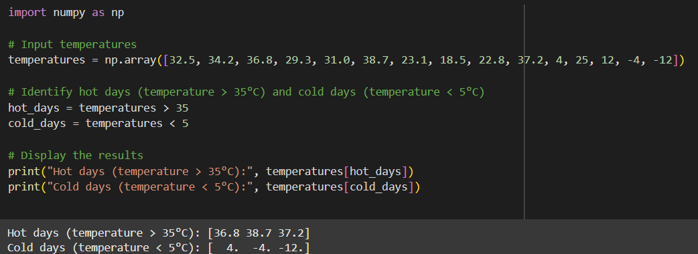

2. Suppose you have a dataset containing monthly sales data for a company, and you want to split this data into quarterly reports for analysis and reporting purposes.

Input: monthly_sales = np.array([120, 135, 148, 165, 180, 155, 168, 190, 205, 198, 210, 225])

